Project Title:-
PSTU Blended Learning Center (PBLC)
Motive of the Project:-
The motive of the PSTU Blended Learning Center (PBLC) project is to develop a robust and user-friendly online platform that improves the quality of education by connecting students and teachers in a collaborative environment. The system aims to make educational resources such as lectures, notes, and assignments easily accessible while enabling teachers to effectively monitor and evaluate student progress.
By providing course-specific access, structured Q&A, and integrated group discussions, the PBLC fosters meaningful academic interactions, encourages knowledge sharing, and promotes collaborative learning. Ultimately, the project seeks to create an organized, engaging, and efficient learning environment that supports both students and teachers in achieving their academic goals.

Project Objective
The primary objective of the PSTU Blended Learning Center (PBLC) is to establish a comprehensive web-based platform that seamlessly integrates learning and academic interaction between students and teachers. This system enables students to efficiently access lectures, course materials, and assignments, while providing teachers with the capability to monitor, evaluate, and track student performance. Furthermore, the platform incorporates course-specific access to resources, a structured Q&A feature, and integrated group discussions to promote collaborative learning and knowledge sharing. Overall, this LMS ensures organized learning, strengthens student engagement, and enhances effective course management within educational institutions.
Key Points:
- Enable students to access lectures, notes, and assignments online.
- Allow teachers to monitor and track student performance efficiently.
- Facilitate interactive Q&A between students and teachers.
- Ensure that questions and answers are organized by specific course and department.
Enhance student engagement and streamline course management.
Technical Requirements:-
Backend: PHP
Frontend: HTML, CSS, JavaScript
Database: MySQL

Limitations of the Project:-
• The system requires a stable internet connection for students and teachers to access lectures, assignments, and Q&A features.
• Performance may be affected if a large number of users access the platform simultaneously, depending on server capacity.
• The platform relies on proper database maintenance; improper handling may lead to data inconsistencies.
• Advanced features like real-time notifications, video streaming, or mobile application support are not included in the current version.
• User interface customization is limited, and it may require additional effort to make the platform fully responsive across all devices.

Benchmark Table for Blended Learning Center
Feature / Parameter | PBLC (Our Project) | DIU -  BLC | Burstow Park School | Hurix Digital Blended Learning | FHGR BLC | BLSC
Login | ✔ | ✔ | ✘ | ✘ | ✘ | ✔
Online Access to Lectures/Notes | ✔ | ✔ | ✔ | ✔ | ✔ | ✔
Assignment Upload & Submission | ✔ | ✔ | ✘ | ✘ | ✘ | ✔
Student Performance Tracking | ✔ | ✔ | ✘ | ✘ | ✘ | ✔
Interactive Q&A Section | ✔ | ✔ | ✘ | ✘ | ✘ | ✘
Course-specific Resource Access | ✔ | ✔ | ✔ | ✔ | ✔ | ✔
Group Discussion / Collaboration | ✔ | ✔ | ✘ | ✘ | ✘ | ✘
Video  Lectures | ✔ | ✔ | ✘ | ✔ | ✔ | ✔
Mobile Application Support | ✔ | ✘ | ✘ | ✘ | ✘ | ✘
Responsive User Interface | ✔ | ✔ | ✔ | ✔ | ✔ | ✔

- PBLC- PSTU Blended Learning Center
- DIU BLC - DIU Blended Learning Center
- FHGR BLC- Fachhochschule Graubunder Blended Learning Center

Sitemap:
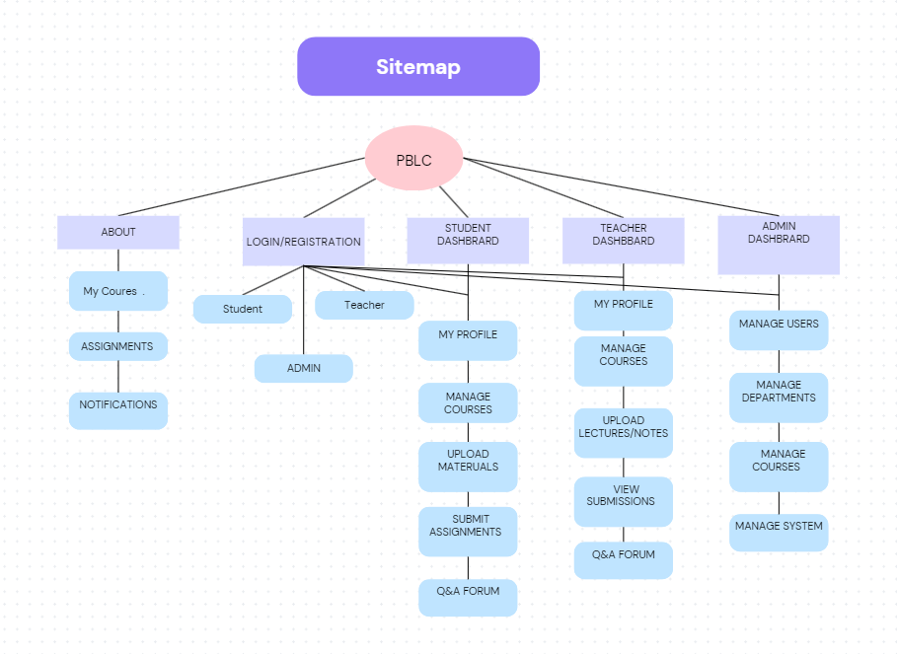

DFD (Data Flow Diagram):

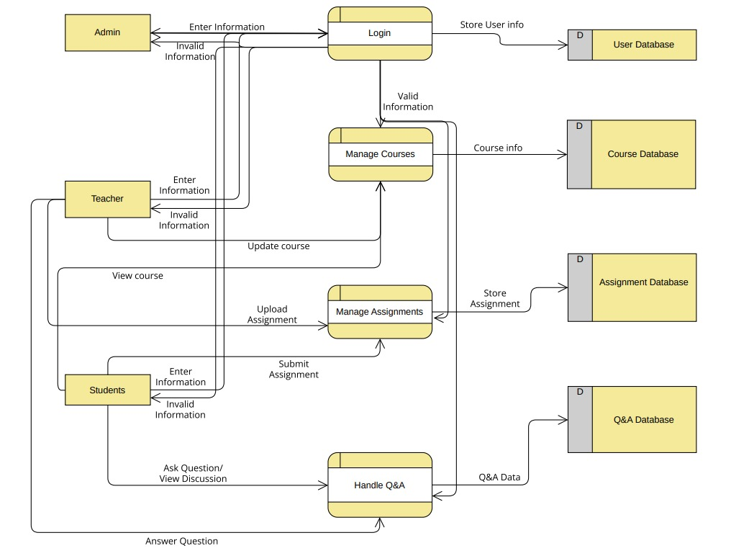

Context Diagram:
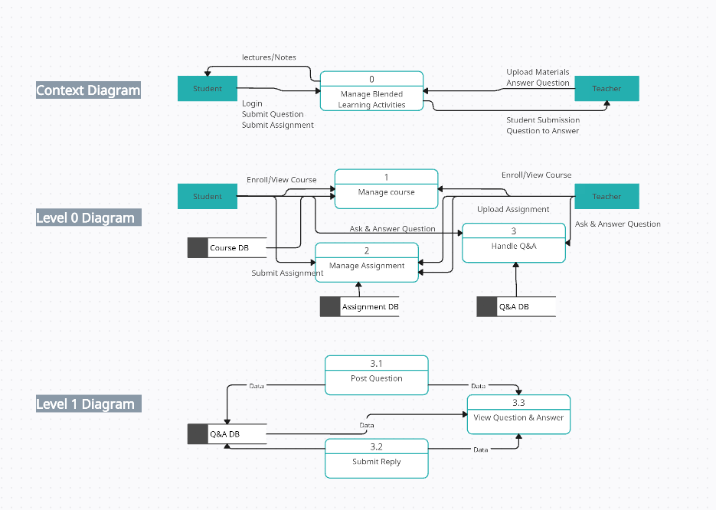

Activity Diagram:
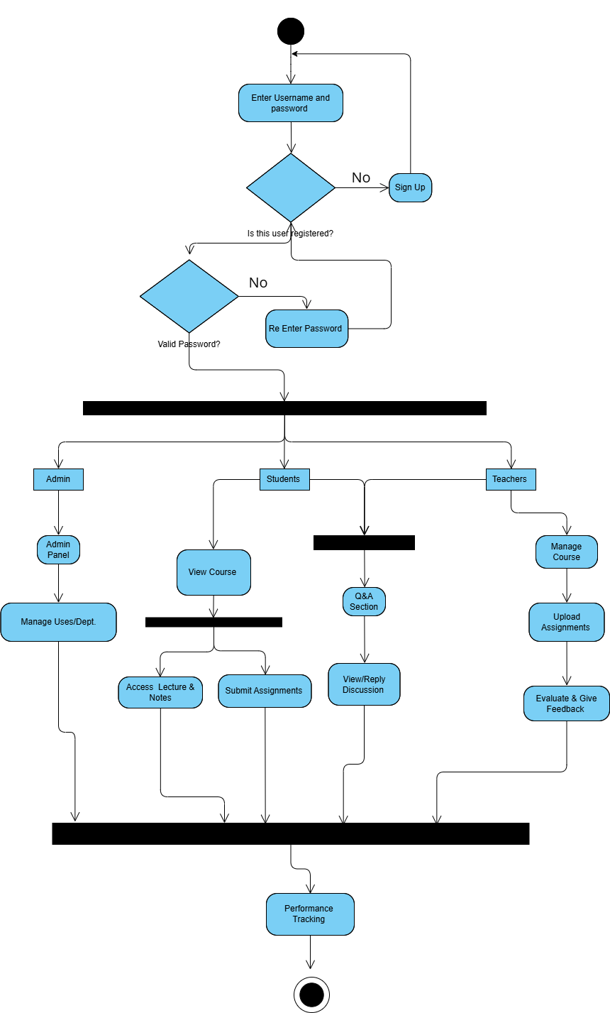

Use Case Diagram:
